Portsoy Church Profile

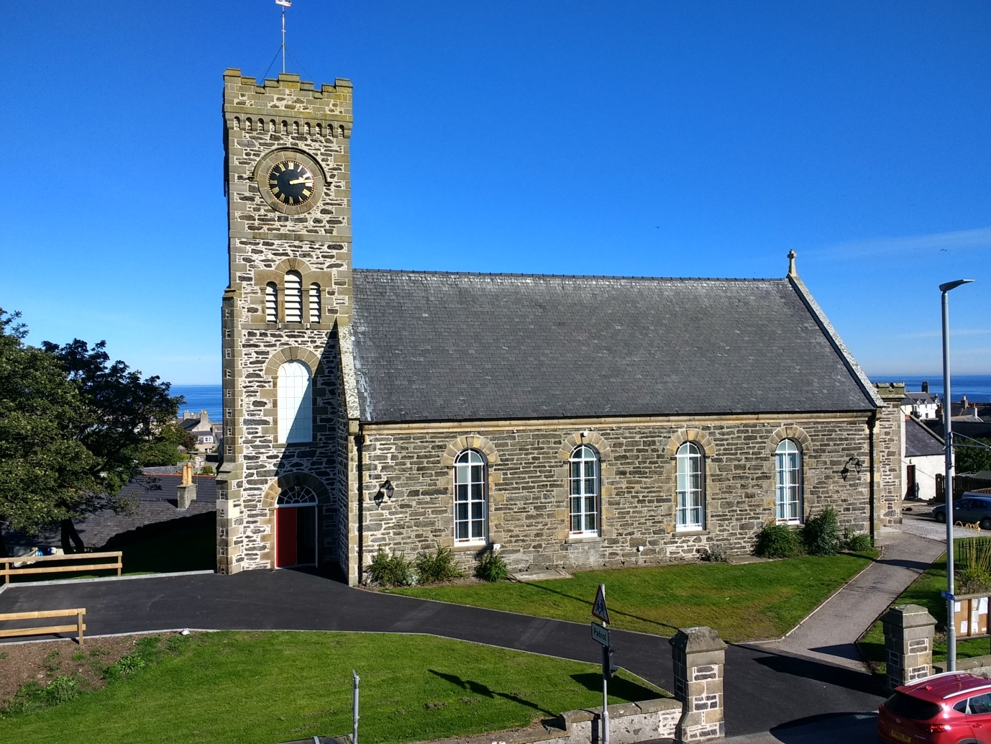

WELCOME

Welcome to our Parish Profile. Whether you are a new minister, a minister seeking a change or just want to learn more about us in Portsoy we hope you enjoy reading all about the Portsoy Church Family and our vibrant local community.

Mission Statement

We aim to serve God daily through praise, worship
and friendship
and serve our community offering hope, direction and purpose
by sharing the love of Jesus Christ.

“We love because God first loved us”
1 John Ch 4 vs 19

Portsoy Church SC000522

All about us in Portsoy

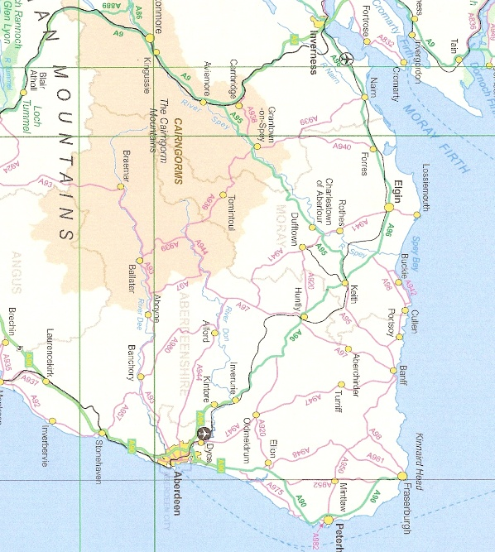
Portsoy Church is located on the Moray Coast serving the neighbouring villages of Sandend and Fordyce as well as the town of Portsoy.
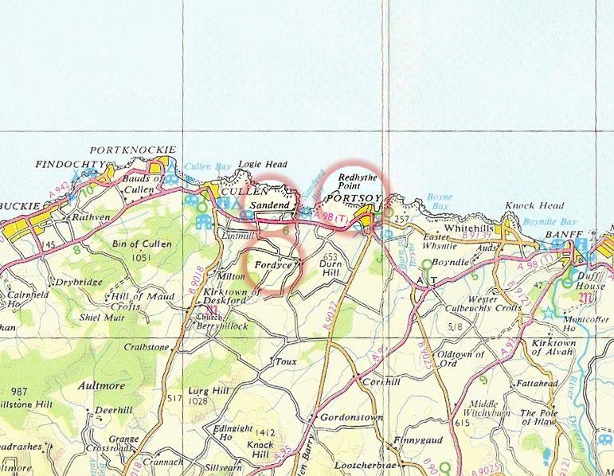
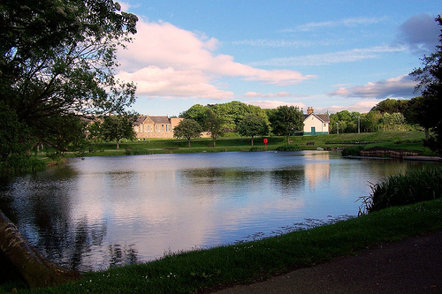
Portsoy is a busy friendly town eight miles from Banff on the Moray Firth and has a population of approximately 2000. It enjoys an equitable coastal climate with milder winters and pleasant summers. At one time it was a prominent trading town, the history of which can be found in the Salmon Bothy now our local museum. The town is a bustling tourist centre with the annual Scottish Traditional Boat Festival, Folk festivals, Book festivals and a large wool and craft festival drawing large numbers to the town. The Boat Festival in particular attracts upwards of 16,000 every year. The 17th Century Harbour and the area around it are popular tourist destinations all year round. The Church Guild provides teas, coffees, sandwiches and cakes on the Saturday of the Boat Festival. The busy caravan site and bunk house on Links Bay also brings in numbers of tourists.
Loch Soy located in the centre of the town with the primary school and the old railway station (now the Scout hut) in the background

There is no shortage of clubs and activities in the town, including a bowling club, inshore rowing club, folk club, over 60s club, fundraising ‘75’ club, the Bothy Knitters craft group and the Soy singers. For children and young people there are brownie and scout groups, army cadet group, and the award winning Portsoy Skippers. The town also has its own Pipe Band as well as a gym, sports facilities and children's playparks.

Portsoy and Fordyce each have a primary school and there is a mums and toddlers group in the town and a nursery attached to Portsoy School. After their primary education, the children attend Banff Academy and are transported there by bus.

There are two sheltered housing complexes and a care home in the town, as well as a doctors’ surgery. We have an excellent range of shops for a small town including a Co-op store along with two craft bakers, cafes, a pharmacy and not forgetting the wonderful Portsoy ice-cream shop and Post Office, providing a range of groceries and other goods. There is also an antique shop and a gift shop.
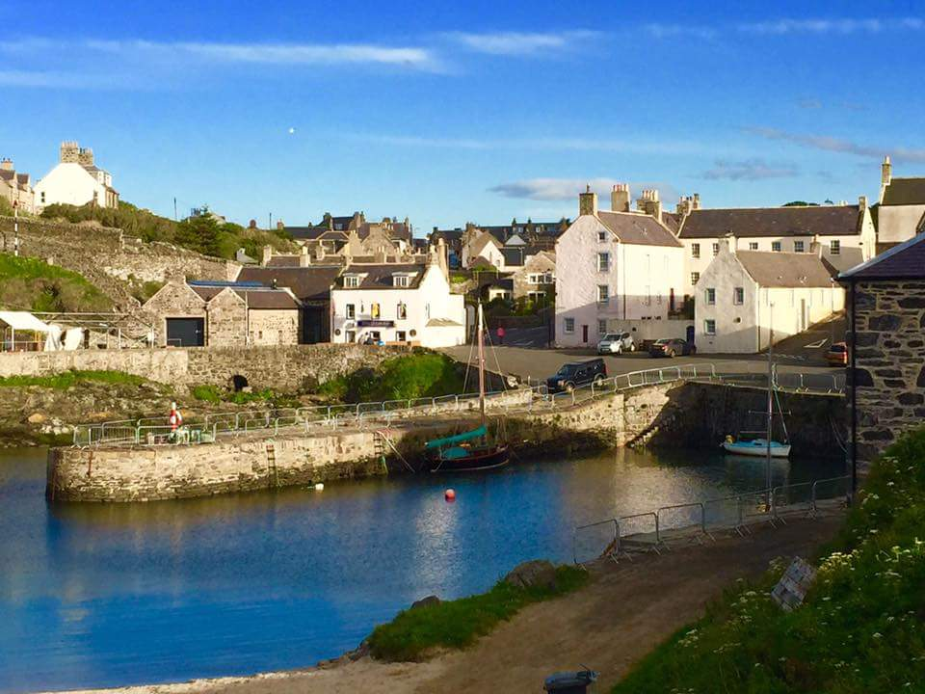

Portsoy Old Harbour

The village of Fordyce is a small and very attractive settlement, particularly in the spring and summer when the gardens are in flower. Its origins date back some 1400 years when the Old Church, now a ruin, was founded by St Tarquin. Fordyce Church, which was linked with Portsoy, closed and was sold. It is now a popular Bistro.

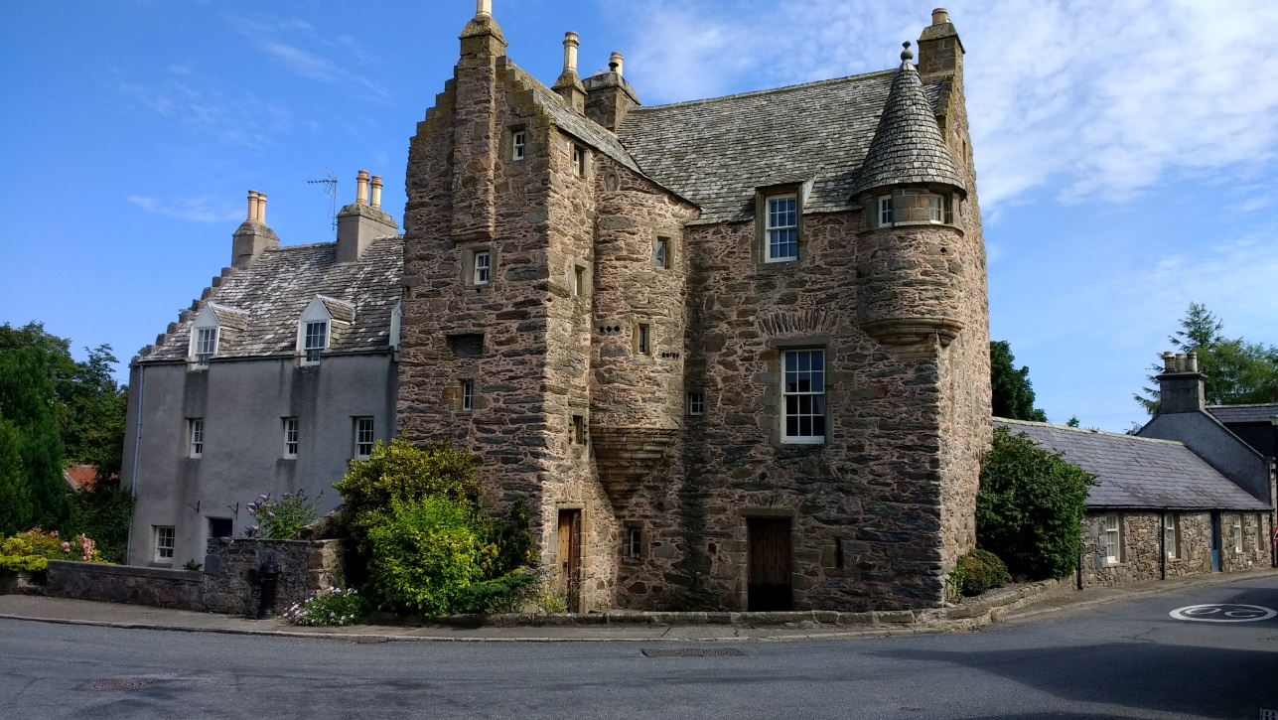
Fordyce Castle
Sandend is one of the smallest of the old fishing villages along the Moray Firth. It is 2 miles along the coast from Portsoy and is popular with surfers, dog walkers and families enjoying the long sandy beach.

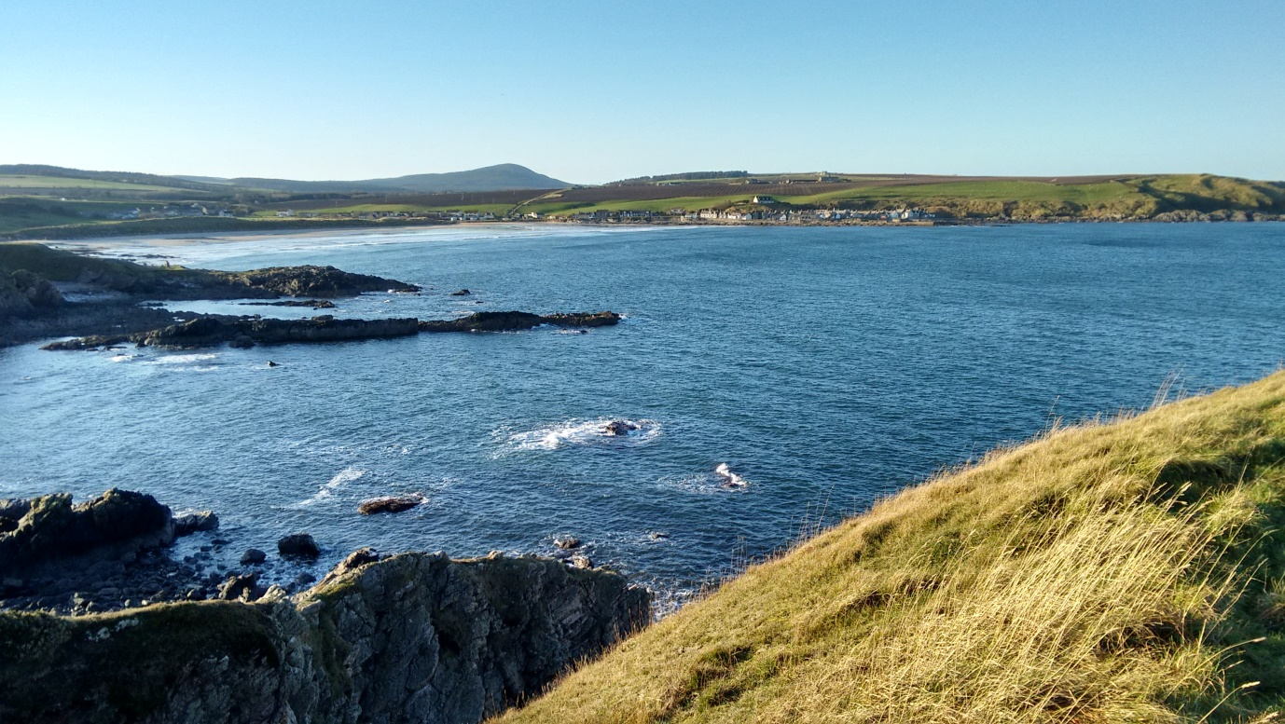
Sandend Bay with the village in the background

Our Church

The call— We require a new minister because Rev Norman Nicoll has moved away to St Andrew’s Church in Corby, Northamptonshire. He was with us for seven years.
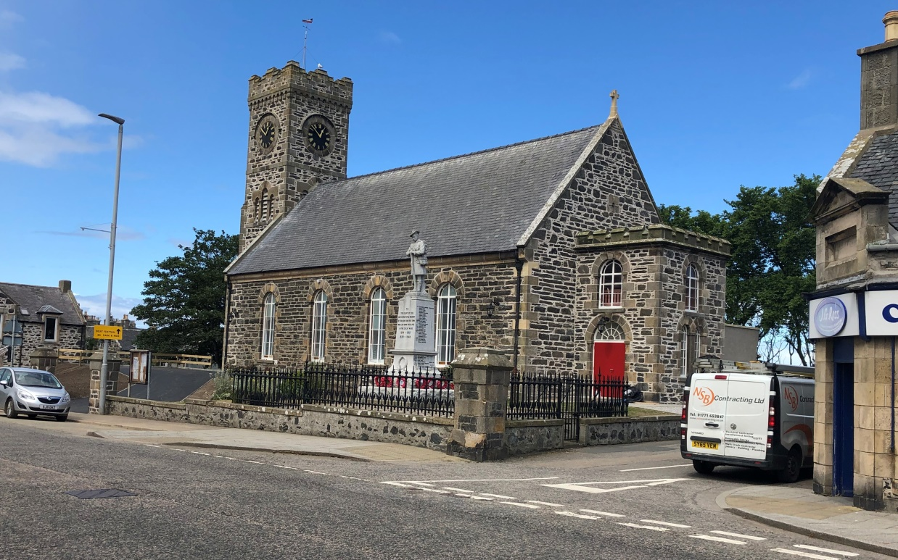

Our new Church Centre and Parish Church is in the centre of the town ofPortsoy

We currently have 301 on the roll and hold a service each Sunday at 10.30 am in the Church Centre with refreshments afterwards. The new Church Centre serves both as our Parish Church and a multipurpose facility for the Church and the wider community. We are currently in the process of seeking permission to dispose of the former Church building which we hope will be sold in due course. The Church Centre is our main centre for social activities and outreach.

In the past the parish minister has also been invited to be chaplain at the local care homes.

Unitary Constitution

We adopted a Unitary Constitution in 2013. Various Groups have been set up made up of Elders and members of the congregation. The Groups are:

♦ Pastoral Care
♦ Outreach
♦ Finance and Property
♦ Social

Kirk Session has 11 elders - 8 female and 3 male members with a wide range of experience. The Session works well as a team and gives the Minister their full support. It meets about 5 times a year.

The Manse

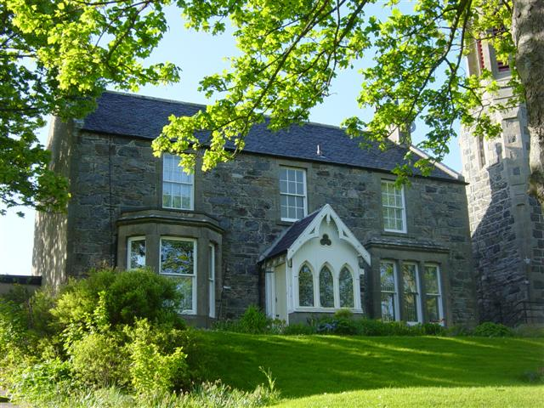
Our Manse is a traditional detached stone built ‘B’ listed house, which is adjacent to the former Church building and situated within walking distance of the town centre. It is south facing and double-glazed and carpeted throughout with full gas central heating. On the ground floor it has two large public rooms and a modern kitchen which leads on to a utility room. There is also a downstairs shower room and toilet, and a study. A wide sweeping staircase leads upstairs to four large double bedrooms and a bathroom. Outside is a large garden with a summer house and outside storage area. To the rear is a garage and parking space.

Any decoration and replacement of carpets which is required will be undertaken with the wishes of the new minister taken into consideration.

Our New Church Building

Over the years it had become apparent that the cost of maintaining 2 separate buildings was not in the best interests of the church, neither financially nor from the point of view of growing God’s kingdom here in the Parish. After much prayerful consideration and discussion with members, it was agreed that the way ahead lay in a complete refurbishment and extension of the church hall which was formerly the town’s ‘Auld Kirk’ before its conversion for use as a Church Hall in the 1950s.

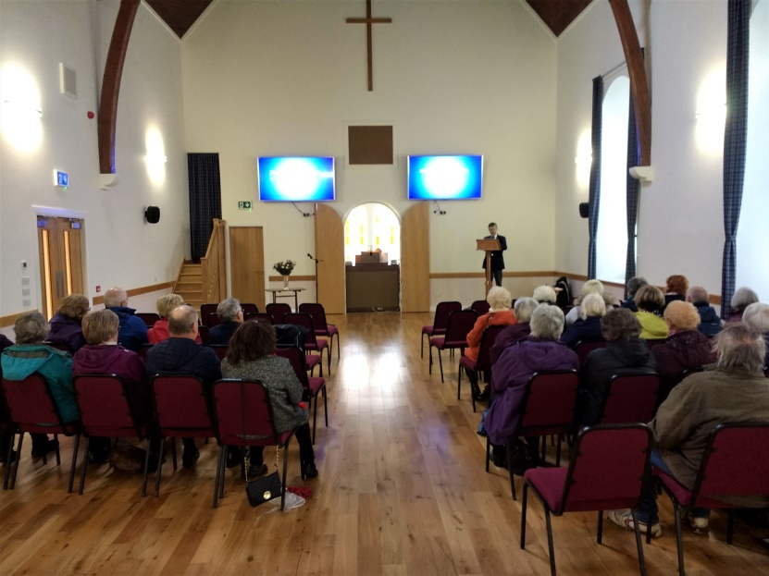
The vision behind this project was to give us a Church complex in the heart of Portsoy with facilities that meet the needs of our congregation and parish community - a church for the future and a legacy for our children. It is about giving us a base from which to develop our activities in all parts of our Parish and hopefully reverse the gradual decline in our active membership. This building has better access and parking than the current church and is already well used by the various church groups and other community organisations.
Sunday service

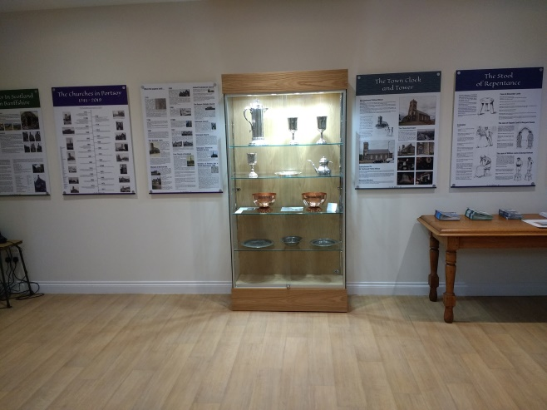
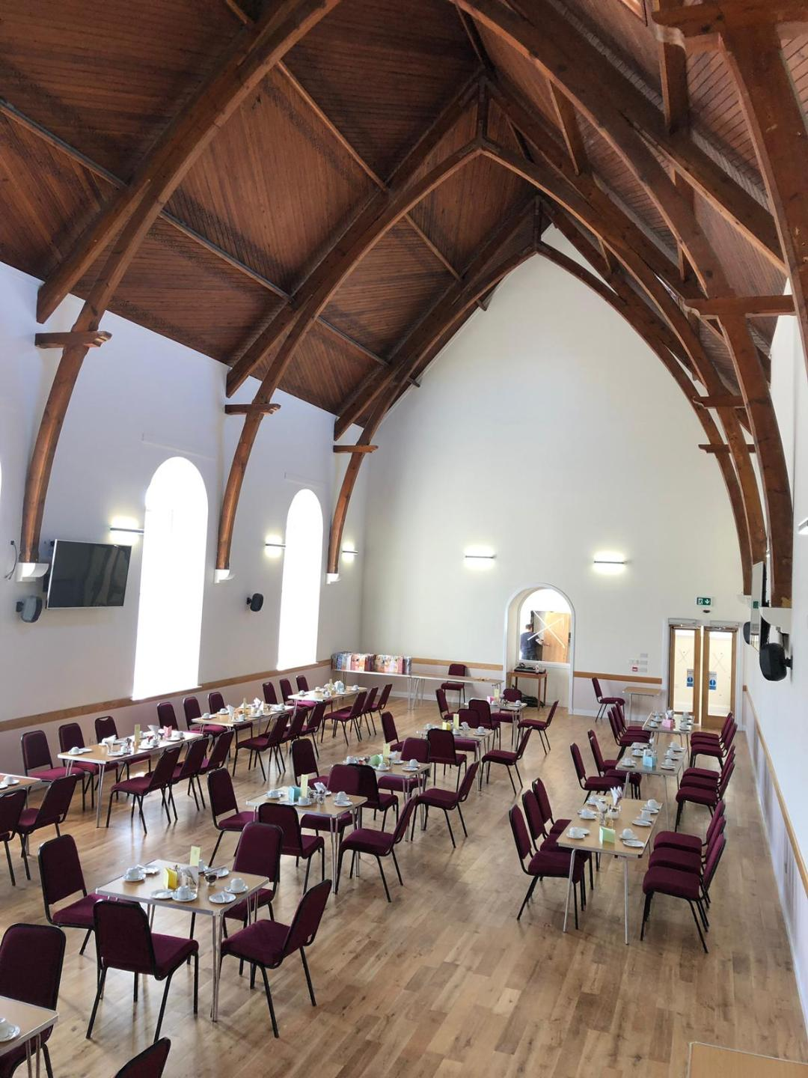
The redevelopment project, which had been in the planning for over 5 years, was based on what has been shown to work for churches today, but looking further forward to the future. It offers flexible spaces for different kinds of use; modern facilities (kitchen, toilets, flexible meeting room, an enlarged hall/sanctuary with better access, all friendly to disabled people); a welcome not only to worship but to belonging; a close interaction and relationship with the whole parish community; and a strong sense of ownership in terms of mission, stewardship, and care.
Heritage Exhibition in the meeting room
Main hall/sanctuary set out for Boat Festival Teas

With eco-friendly heat pump providing underfloor heating the building provides a warm welcoming space accessible and usable by all in our parish. It will, however, always be a sacred space for worship and witness, keeping our Christian identity. This will be the legacy we pass on to the following generations of Christians, and this, we believe, is the way forward.

The building now officially known as Portsoy Church Centre was formally rededicated by Presbytery as Portsoy Parish Church on 6th September 2019.

How we work as a congregation
Prayer in the Church

We have a Prayer Circle which began with just a few people but over the years it has grown to nearly 30 members of all ages. Prayer requests are given to the Prayer Secretary who then circulates them. Requests come not only from people of the Parish but also from others further afield.

Each week a prayer topic is inserted into the Church Family News. This may be for something topical or for issues and people worldwide.

An article on prayer is featured in the monthly magazine Focus and the topics vary greatly from biblical thoughts to items of interest, which may be affecting us in some way that month.

Prayer Group

A small group of members meet weekly in the Church Centre meeting room for prayer. We have prayed for Portsoy street-by-street and are now praying to the Lord to send His person to be the next 'shepherd of the flock' here in Portsoy.

Pastoral Care Team

We have a Pastoral Care Team which complements the work of the Minister by visiting the elderly, housebound, sick and bereaved in our parish. Members record the Sunday services and deliver them in CD format to those unable to attend church. Sunday flowers are taken to those who are ill or bereaved, or alternatively celebrating a special occasion. Similarly, cards are sent for the same reasons. The team has also forged strong links with SACRO Supported Accommodation in Elgin and delivers goods donated by the congregation.

The Guild

There is a thriving Guild of around 20 members who meet monthly on a Tuesday afternoon in the Church Centre meeting room from mid-September to the end of March. It has a varied and interesting programme with speakers on topics related to the Guild theme, our Christian life and other topics of interest.
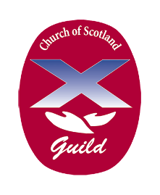
On a practical level members serve teas in the Church Centre on the Saturday of the Boat Festival and the weeklong thrift shop in July has become an established tradition in the town. These events enable financial support of the church and Guild projects. Guild members are friendly and welcoming and, while mindful of the motto “Whose we are and whom we serve,” the non-threatening atmosphere has proved to be an ideal introduction to the Church for those with no existing connection.

Coffee ‘n’ Company

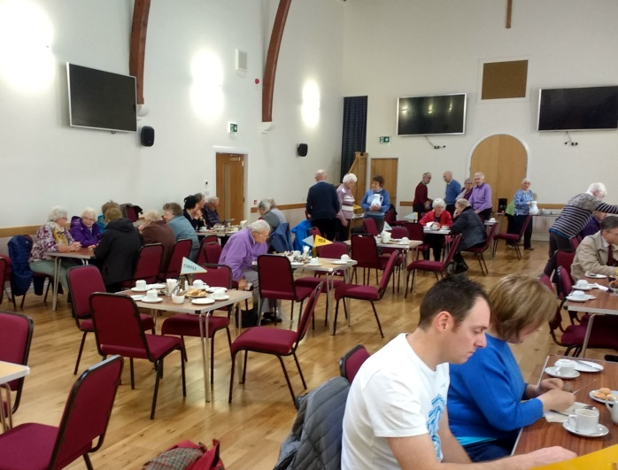
Coffee ‘n’ Company was set up as a weekly outreach in 2004 to make the Church known to the community. Initially held in the old meeting room success soon overtook it and now up to 100 people meet on a Tuesday morning and are served tea, coffee and home bakes by a rota of helpers. There is no charge but any donations are passed to various causes. Most people attending are regulars which means that although this may be their only contact with the Church they can be helped in time of need. It is our prayer that as they are now meeting in what is also the Church Sanctuary more and more will be encouraged to come to the Church for services as well.

At Easter, Harvest and Christmas we sing appropriate hymns and have short bible readings relevant to the season. Feedback from the community has been excellent.

The Well Cafe

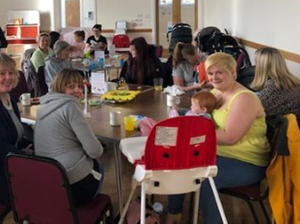
The Well Cafe is aimed at the 20's to 40's age group, male or female with pre-school children. It meets on a Friday morning from 9.15am till 11.00am during school term time. Our friendly team of Christian helpers serve tea, coffee, fruit, home baking, biscuits, milk and juice.

Although free, any donations are sent to Childcare International to support its work in Vietnam. Relationships have been built up through time and people realise that this is a safe place to meet friends and chat – a place to relax.

Stewardship of Time, Talents and Giving

The exciting focus of our ongoing Stewardship Campaign has been on encouraging members of our congregation to discover and use their God-given gifts and talents. This is activating the Body of Christ to serve within our church, community and wider world. Members are blossoming as they accept opportunities to try out, train and develop in their various gifts within the safety of this loving congregation.

Music
We are fortunate to have accomplished organists and have recently been gifted a new organ for our Church Centre. For occasions when our organists are not able to perform at our services we have purchased an electronic hymnal to support our worship.

Website

The church’s website www.portsoychurch.org provides information on our service times and forthcoming events, allows access to our weekly Church Family News and provides a selection of photographs.

Church Family News and FOCUS

Church Family News (CFN) is a weekly information and prayer sheet which is available to view in the church and online in the Church’s website. Our bi-monthly FOCUS parish magazine provides news and information on parish activities. It is distributed to all members. Additional copies are provided for visitors and others at events and Coffee and Company and it is also available on our website.

Fairtrade

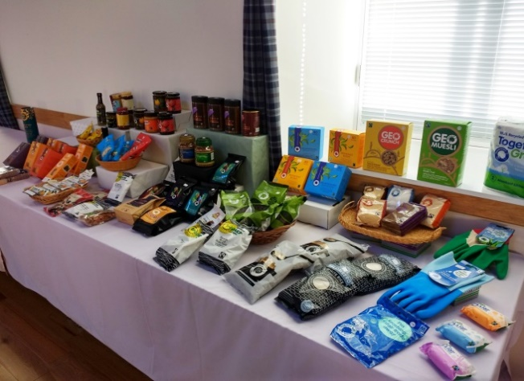
We use all Fairtrade coffee, tea, sugar, cleansing products and even toilet rolls! There is a regular stall at the church as well as weekly opportunities to purchase items at Coffee ‘n’ Company. Our representative can also order goods from the catalogue and gift items are extremely popular at Christmas time.

Horticultural Association

There are two shows held each year and the main aim is to encourage the green-fingered people in the area, and also all the children from Pre School to the Academy. The shows are well attended by the public and competitors demonstrate their skills in growing produce for the show, as well as crafts and baking.

Social Group
The Social Group is responsible for organising several events throughout the year. These have included a Soup and Sweet, Plant Sale and Coffee Morning, summer bus outings, BBQs, a Military Wives Choir Concert and Christmas parties.

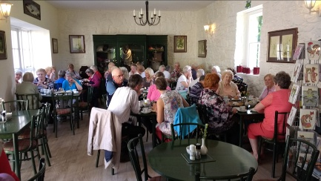
Enjoying afternoon tea during the bus run to Balindalloch

As a congregation we look forward to welcoming our new minister who will share our vision and aims for the future:

Vision
- To be an open God-centred church with more people particularly families and young people, attending informal and lively services
- To see more people in Portsoy and district come to a living, personal faith in Christ
- For our Church Centre to be a warm, welcoming, safe place in the heart of the town where all people can feel they belong

Aims

- To continue to welcome all with friendship and care sharing our enthusiasm and commitment
- To make the new Church centre a focus of worship and other activities for both the Church Family and the wider community
- To maintain and build on our existing organisations within the Church.
- To ensure our new minister is provided with the support and commitment needed to deliver our vision

With God’s guidance we are looking for a new Minister who will

- Be dynamic and able to spiritually inspire the congregation and with our support reach out to all in the community
- Be a people person, friendly, outgoing and approachable
- Be adaptable, flexible, innovative and bring new ideas for worship and outreach
- Be imaginative in meeting the challenges that a multipurpose Church Centre brings in order to maximise the benefits of the building both for the Church Family and the wider community
- Deliver informal, uplifting and varied services
- Share our desire for an emphasis on contemporary, hymns and songs along with the best of the older hymns.
- Use scripture to provide engaging, understandable sermons applied to everyday life experiences
- Be balanced in spiritual outlook and understanding of the variations in human nature.

If you have any queries or would like to see a copy of the Church financial statement, please do not hesitate to contact:

Mrs Ishbel Mackinnon
Treasurer/Clerk to Nominating Committee
“Deveron”
17 Durn Road
Portsoy
Aberdeenshire
AB45 2QD
e-mail: ishbel.mackinnon@btinternet.com

Or alternatively:

Informal enquiries can be made to the Interim Moderator:
Rev Kevin Gruer
Tel: 01888 563850 or e-mail kgruer@churchofscoltland.org.uk

